# CS 255 System Design Document Template

This template lays out all the different sections that you need to complete for Project Two. Each section has guidance to prompt your thinking. You will need to continually reference the interview transcript as you work to make sure that you are addressing your client’s needs. There is no required length for the final document. Instead the goal is to complete each section based on what your client’s needs are. Remove this note when you are finished, and replace all bracketed text with the relevant information.

## UML Diagrams

Mariah Perez

Dec 10, 2023

### UML Use Case Diagram

### UML Activity Diagrams

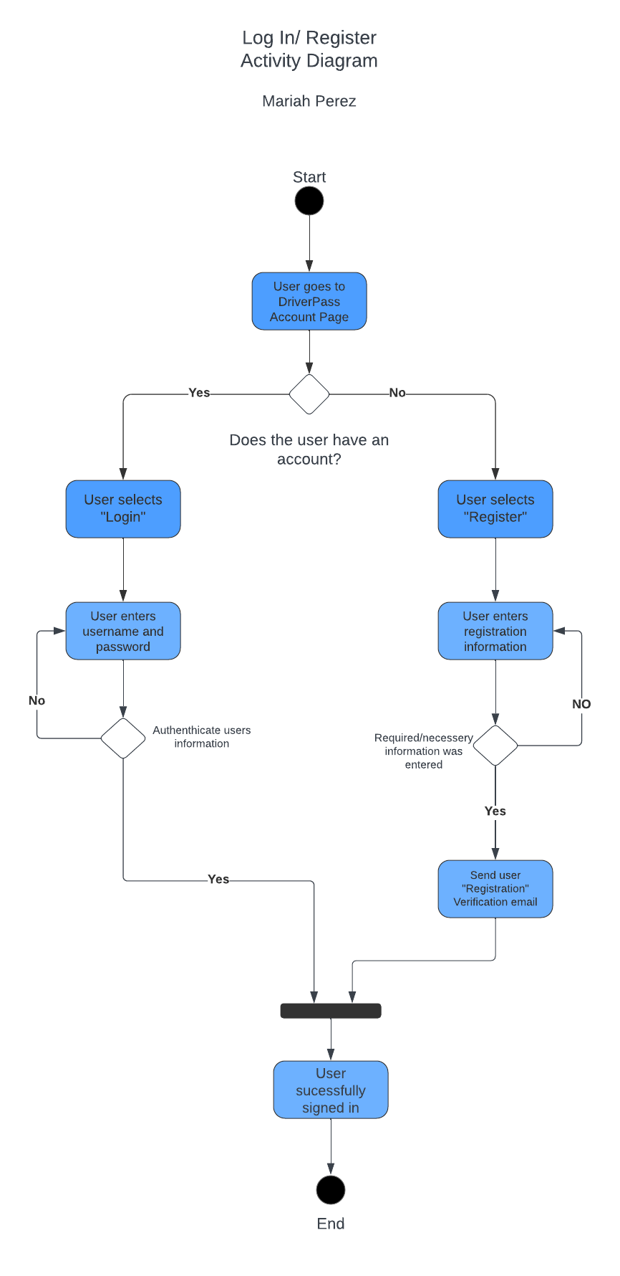

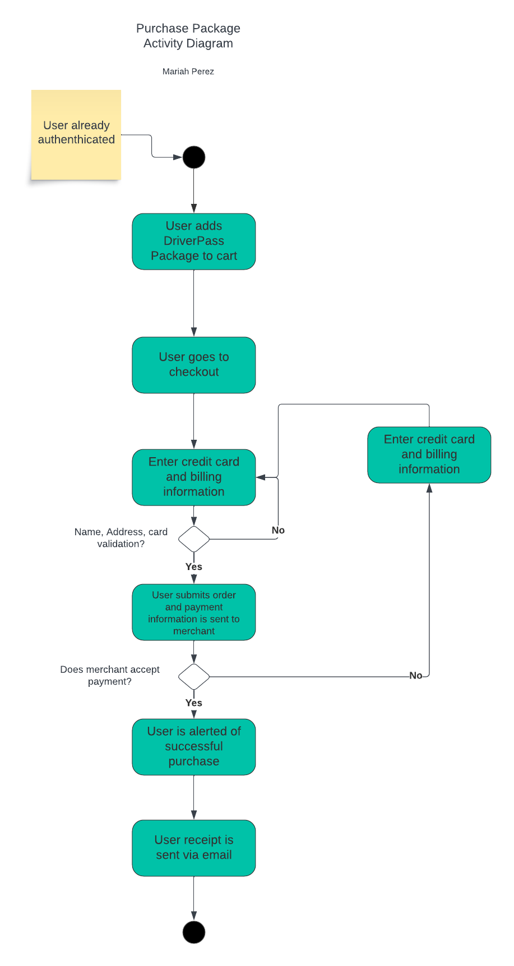

### UML Sequence Diagram

### UML Class Diagram

## Technical Requirements

**Technical Requirements for System Design:**

1. **Hardware:**
   * Dedicated Server:
     + Employ a robust dedicated server for hosting the DriverPass system, ensuring optimal performance and reliability.
   * Internet Connection:
     + Establish a high-speed and stable internet connection to facilitate seamless user interactions with the website.
     + Storage for Database and Website Data:
     + Implement sufficient storage capacity for both the database and website data, ensuring efficient data management.
   * Computer or Mobile Device for User Access:
   * Allow users to access the website from computers or mobile devices, ensuring a versatile user experience.

* Firewall for Website Ports:
  + Deploy a firewall to safeguard website ports, enhancing security against potential cyber threats.

1. **Software:**

* Windows Server (Recommended):
  + Utilize Windows Server, opting for the most stable release to ensure a reliable operating environment.
  + SQL Server for Database (Recommended):
  + Implement SQL Server for the database, choosing the most stable release for optimal data management.
* Backup Software:
  + Employ backup software to regularly backup website and database data, ensuring data integrity and availability.
* Web Server (e.g., Apache):
  + Set up a web server, such as Apache, to facilitate the hosting and delivery of web content.
* Security Software:
  + Install security software to prevent malware and enhance overall system security.

1. **Geographic Information:**

* Accessibility in America:
  + Ensure the website is accessible in America, aligning with the geographic requirements outlined by the client.
* Secured Server in Data Center:
  + Place the server for both the website and database in a secure data center, enhancing physical and digital security.
* Central Location for Server:
  + Position the server in a central location, optimizing accessibility and reducing latency for users across different regions.

These technical requirements encompass hardware specifications, software selections, and geographic considerations, all designed to meet the client's needs and ensure the robustness and security of the DriverPass system.